Docker Commands to build image and run it
Inside Terminal/cmd of Visual Studio Code:
PS C:\docker_practice> docker -v
Docker version 29.7.2, build a7dcaa6
Code – for docker-welcome-app image:
C:\docker_practice\welcome-app\Hello_World_Image.py
from fastapi import FastAPI
import uvicorn
app = FastAPI()

@app.get("/")
def hello_world():
# return {"message": "Hello User,Welcome to the Docker World!"}
return "Hello User,Welcome to the Docker World!"

if __name__ == "__main__":
# uvicorn.run(app, host="127.0.0.1", port=8000)
uvicorn.run(app, host="0.0.0.0", port=7000)
C:\docker_practice\welcome-app\Dockerfile
FROM python:3.11-alpine
COPY . /docker_app
WORKDIR /docker_app
RUN pip install -r requirements.txt
CMD ["python" , "Hello_World_Image.py"]
C:\docker_practice\welcome-app\requirements.txt
fastapi
uvicorn
----------------------------------------------------

PS C:\docker_practice> docker build -t docker-welcome-app .
[+] Building 34.3s (10/10) FINISHED docker:desktop-linux
=> [internal] load build definition from Dockerfile 0.2s
=> => transferring dockerfile: 180B 0.1s
=> [internal] load metadata for docker.io/library/python:3.11-alpine 5.4s
=> [auth] library/python:pull token for registry-1.docker.io 0.0s
=> [internal] load .dockerignore 0.0s
=> => transferring context: 2B 0.0s
=> [internal] load build context 0.5s
=> => transferring context: 6.40MB 0.5s
=> [1/4] FROM docker.io/library/python:3.11-alpine@sha256:0d55920083f1ce1e38ac292e2772f924b4f8bb4 7.5s
=> => resolve docker.io/library/python:3.11-alpine@sha256:0d55920083f1ce1e38ac292e2772f924b4f8bb4 0.0s
=> => sha256:d429b507940f71801c97252dc25f1745f4dc05b8eab6a41301a381723dce785e 247B / 247B 0.4s
=> => sha256:de89dd2005c38681e92ac710c968f57b520b8f3a7f07f8bc22ea5b0cb47c2816 18.71MB / 18.71MB 5.6s
=> => sha256:0a15639a78ae211fa184cbd3e3e33a5feadba92ad570fa8519d5c6501e17fdca 408.09kB / 408.09kB 1.5s
=> => sha256:55afa1ecc21d2bb5e5045f32dafee56272ffd89860bac26f6c32123439af26a4 3.85MB / 3.85MB 4.2s
=> => extracting sha256:55afa1ecc21d2bb5e5045f32dafee56272ffd89860bac26f6c32123439af26a4 1.7s
=> => extracting sha256:0a15639a78ae211fa184cbd3e3e33a5feadba92ad570fa8519d5c6501e17fdca 0.4s
=> => extracting sha256:de89dd2005c38681e92ac710c968f57b520b8f3a7f07f8bc22ea5b0cb47c2816 0.5s
=> => extracting sha256:d429b507940f71801c97252dc25f1745f4dc05b8eab6a41301a381723dce785e 0.0s
=> [2/4] COPY . /docker_app 0.1s
=> [3/4] WORKDIR /docker_app 0.0s
=> [4/4] RUN pip install -r requirements.txt 13.9s
=> exporting to image 7.1s
=> => exporting layers 6.5s
=> => exporting manifest sha256:65121a60e322525f4a176d28e8ff717c9fec3c641c61c7ff4d2e55e1f368351a 0.0s
=> => exporting config sha256:c538b78100038153fba6bfa709487f85b2bf4a3f3dec2668d00f7e9acb80fb37 0.0s
=> => exporting attestation manifest sha256:98294cf337c4029b8ba7a18a6c0553e7537d7d80a7bf1617f33d2 0.0s
=> => exporting manifest list sha256:871472e49ab6bbe660deed590b75f843bc53b8ef37039c5d9381b7ac32d2 0.0s
=> => naming to docker.io/library/docker-welcome-app:latest 0.0s
=> => unpacking to docker.io/library/docker-welcome-app:latest 0.4s

1 warning found (use docker --debug to expand):
- JSONArgsRecommended: JSON arguments recommended for CMD to prevent unintended behavior related to OS signals (line 5)

View build details: docker-desktop://dashboard/build/desktop-linux/desktop-linux/vouar8fgtzle4ij06e3wly4fg
Note: “-t ”stands for tag (allows you to assign a human-readable name to your image)
PS C:\docker_practice> docker desktop status
Name Value
Status running
SessionID e0a8a16a-b110-4b8b-9da0-177aa2614427
Note: If not running run start command
PS C:\docker_practice> docker desktop start
PS C:\docker_practice> docker ps
CONTAINER ID IMAGE COMMAND CREATED STATUS PORTS NAMES
PS C:\docker_practice> pip list
Package Version Editable project location
----------------------------------------- ----------- -------------------------
annotated-doc 0.0.5
annotated-types 0.8.0
anyio 4.15.1
certifi 2026.4.22
cffi 2.0.0
charset-normalizer 3.4.7
click 8.5.0
cryptography 48.0.0
h11 0.16.0
idna 3.15
install_python_custom_packages 1.0.0 C:\python practice\com
install_serialization_and_deserialization 1.0.0
jsonpickle 4.1.1
numpy 2.4.6
oracledb 4.0.0
pip 26.2.1
pyaml 26.2.1
pycparser 3.0
pydantic 2.13.5
pydantic_core 2.46.5
PyMySQL 1.2.0
python-dateutil 2.9.0.post0
PyYAML 6.0.3
requests 2.34.2
six 1.17.0
starlette 1.6.0
typing_extensions 4.16.0
typing-inspection 0.4.4
tzdata 2026.2
urllib3 2.7.0
PS C:\docker_practice> docker images
i Info → U In Use
IMAGE ID DISK USAGE CONTENT SIZE EXTRA
apache/hive:4.0.1 5194161ef50b 2.77GB 1.15GB U
docker-welcome-app:latest 871472e49ab6 156MB 40.1MB

Note: Code level Modifications ---> sync ---> Docker image
If we do some modifications at code level after creation of docker image to reflect those changes we need to compile code file then rebuild docker image .
Command Compiling python file to sync updates while building docker file image:
PS C:\docker_practice> python -m py_compile < python-file-name> (ex …Hello_world_image.py)
Decode flow:
python: Starts the Python interpreter.
-m: Stands for "module". It tells the Python interpreter to search its library for a specific module and run it as a standalone script.
py_compile: The built-in Python module being called. Its dedicated function is to read a source file and generate a compiled bytecode version of it.
<python-file-name>: The target script you are passing to the module to be compiled (e.g., script.py).

Re-Building Docker Image:
PS C:\docker_practice> docker images
i Info → U In Use
IMAGE ID DISK USAGE CONTENT SIZE EXTRA
apache/hive:4.0.1 5194161ef50b 2.77GB 1.15GB U
docker-welcome-app:latest 8f96a2733a89 156MB 40.1MB
PS C:\docker_practice> docker build -t docker-welcome-app .
[+] Building 1.5s (9/9) FINISHED docker:desktop-linux
=> [internal] load build definition from Dockerfile 0.0s
=> => transferring dockerfile: 184B 0.0s
=> [internal] load metadata for docker.io/library/python:3.11-alpine 1.2s
=> [internal] load .dockerignore 0.0s
=> => transferring context: 2B 0.0s
=> [internal] load build context 0.0s
=> => transferring context: 44.15kB 0.0s
=> [1/4] FROM docker.io/library/python:3.11-alpine@sha256:0d55920083f1ce1e38ac292e2772f924b4f8bb4188d336c79bf66963039e6146 0.0s
=> => resolve docker.io/library/python:3.11-alpine@sha256:0d55920083f1ce1e38ac292e2772f924b4f8bb4188d336c79bf66963039e6146 0.0s
=> CACHED [2/4] COPY . /docker_app 0.0s
=> CACHED [3/4] WORKDIR /docker_app 0.0s
=> CACHED [4/4] RUN pip install -r requirements.txt 0.0s
=> exporting to image 0.1s
=> => exporting layers 0.0s
=> => exporting manifest sha256:c666dd3a188fe19f121a5a89519fec53ab198a2070562e436df8d96f3ee9eab2 0.0s
=> => exporting config sha256:5a7659742da8a0f51fba0ca438d602015dfc67201e64e5184efccc6c51ad5a51 0.0s
=> => exporting attestation manifest sha256:f2ccc4abe22041e60193eabc199ce6514b46bda746917b2bed2eb887aeabcb19 0.0s
=> => exporting manifest list sha256:60aff46757845ba076def86ed06d4b8acf76987037945401df03095a8da917f3 0.0s
=> => naming to docker.io/library/docker-welcome-app:latest 0.0s
=> => unpacking to docker.io/library/docker-welcome-app:latest 0.0s

View build details: docker-desktop://dashboard/build/desktop-linux/desktop-linux/w9o0qye0omlghi2qkwmpy7bob
Note:
Syntax: Docker port mapping uses
> docker run -p host_port:container_port <image-name>
-p flag (Publish): It creates a network bridge between your physical computer (the host) and the container's isolated network.
Ex:
docker run -p 8080:80 nginx means "take the Nginx web server running on port 80 inside the container, and let me access it by typing localhost:8080 into my computer's web browser."
PS C:\docker_practice> docker run -p 7999:7000 docker-welcome-app
INFO: Started server process [1]
INFO: Waiting for application startup.
INFO: Application startup complete.
INFO: Uvicorn running on http://0.0.0.0:7000 (Press CTRL+C to quit)
INFO: 172.17.0.1:58838 - "GET / HTTP/1.1" 200 OK
INFO: 172.17.0.1:58838 - "GET /favicon.ico HTTP/1.1" 404 Not Found
INFO: 172.17.0.1:38272 - "GET / HTTP/1.1" 200 OK
INFO: 172.17.0.1:38272 - "GET /favicon.ico HTTP/1.1" 404 Not Found
INFO: 172.17.0.1:44602 - "GET / HTTP/1.1" 200 OK
INFO: 172.17.0.1:37016 - "GET / HTTP/1.1" 200 OK
INFO: 172.17.0.1:37016 - "GET /favicon.ico HTTP/1.1" 404 Not Found
INFO: 172.17.0.1:35872 - "GET / HTTP/1.1" 200 OK
INFO: 172.17.0.1:35872 - "GET /favicon.ico HTTP/1.1" 404 Not Found
INFO: 172.17.0.1:35882 - "GET / HTTP/1.1" 200 OK
INFO: 172.17.0.1:59346 - "GET / HTTP/1.1" 200 OK
Testing:
Step-1: check by First Hit Containers port http://0.0.0.0:7000
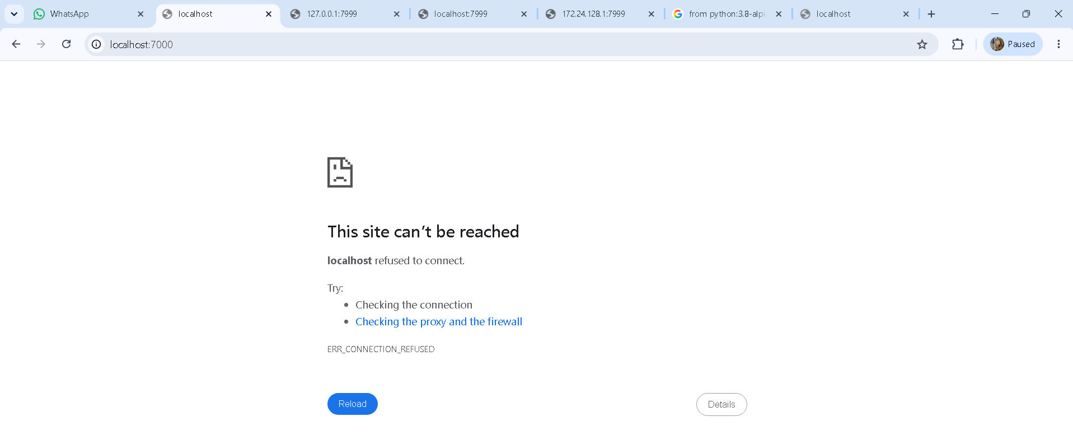

Step-2: device local IPv4 Address. . . . . . . . . . . : 172.24.128.1
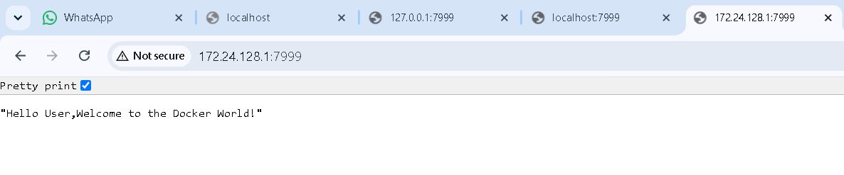
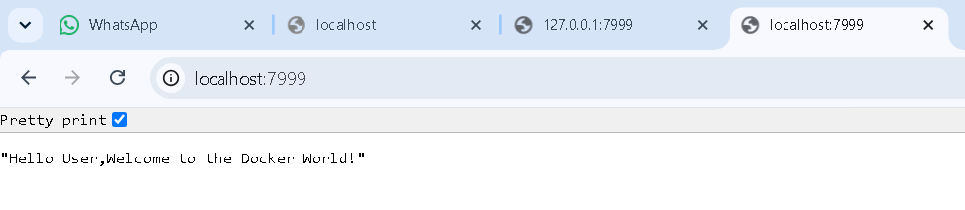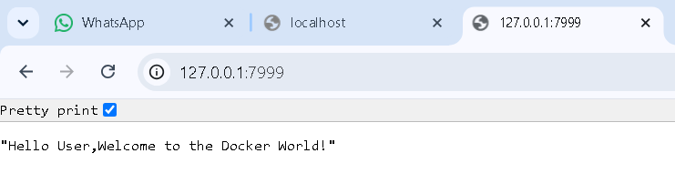
Checking container was created or not :
PS C:\docker_practice> docker ps
CONTAINER ID IMAGE COMMAND CREATED STATUS PORTS NAMES
d5b35ba5dc98 docker-welcome-app "python Hello_World_…" 57 minutes ago Up 57 minutes 0.0.0.0:7999->7000/tcp, [::]:7999->7000/tcp thirsty_haslett
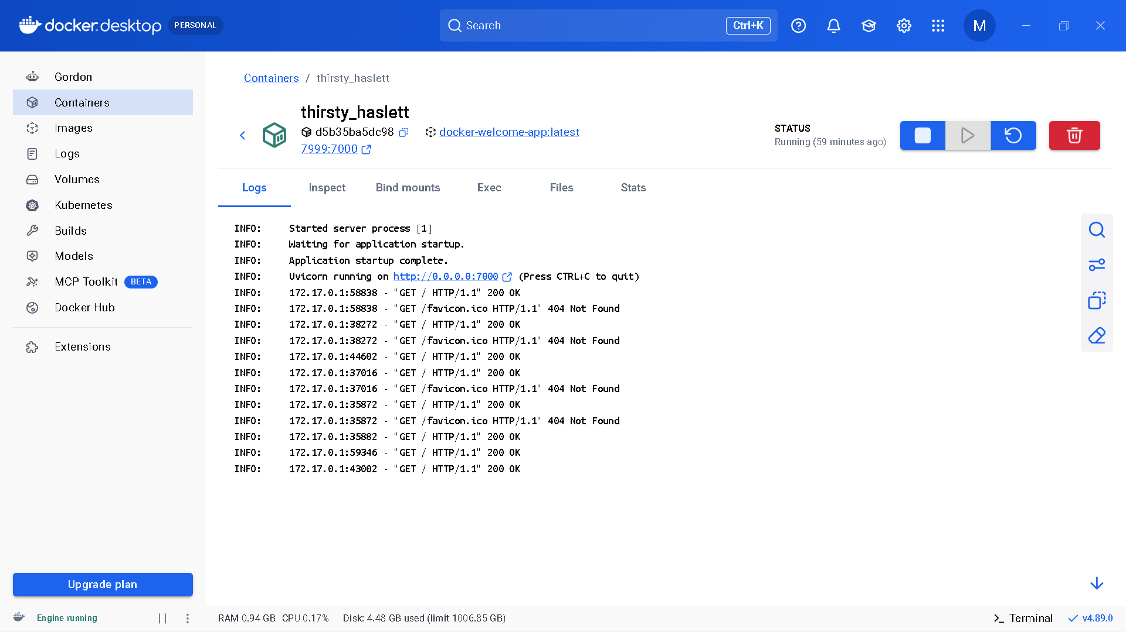

Error case : Already port was allocated and running in background . if we try to run image again with same port configuration . Error will be raises like …….. port is already allocated
PS E:\Docker practic> docker run -p 7000:7000 welcome-app

What's next:
Debug this container error with Gordon → docker ai "help me fix this container error"
docker: Error response from daemon: failed to set up container networking: driver failed programming external connectivity on endpoint stoic_aryabhata (2e52b3080ff67f0561d530b2ec95bbb0d48523085b8f5e8610654730d34d6f83): Bind for 0.0.0.0:7000 failed: port is already allocated
Solution: try to run with already ran image port number. (ex …. http://localhost:7000 --running in background)

Stopping the Docker Container which is currently running:
Command: > docker stop <container-id> (or) Ctrl + C
In terminal :
> docker stop b3ec950cdb9d
b3ec950cdb9d
-------------
In Docker Desktop:
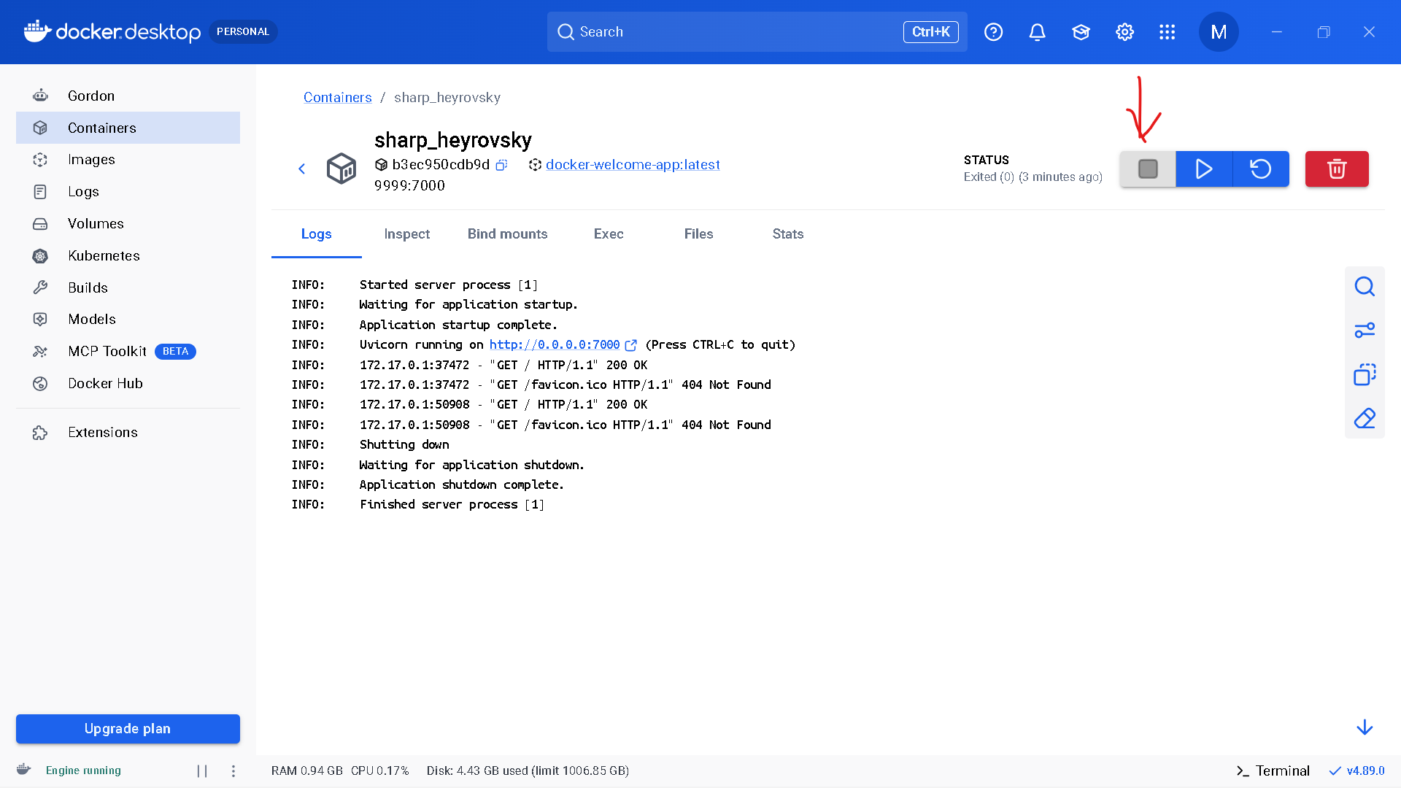

Pull image from Docker Hub Repository
Syntax: docker pull <docker-image-name>
Pulling docker/getting-started Verified Publisher By Docker, Inc. Getting Started tutorial for Docker
> docker pull docker/getting-started
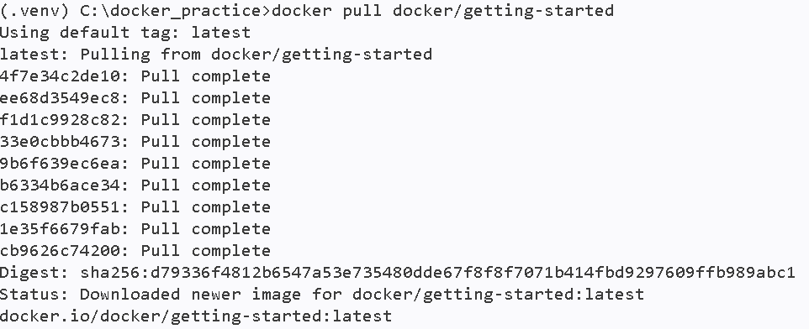
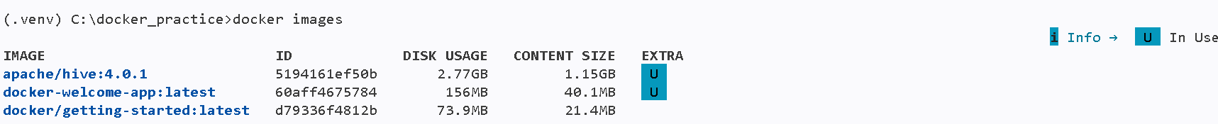
This image contains the Getting Started tutorial for Docker.You can run it locally with the following command:
> docker run -d -p 80:80 docker/getting-started
Testing:
http://localhost:80/
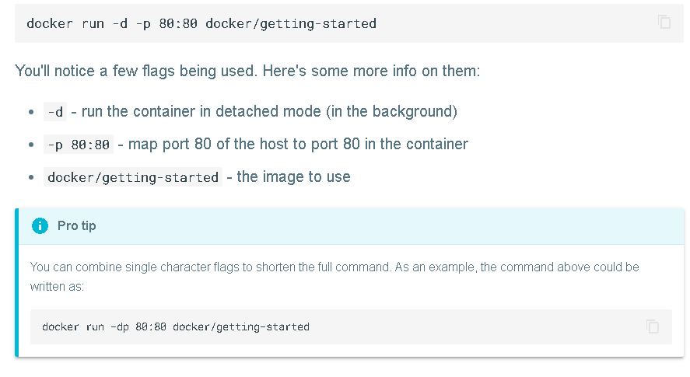
Result link: http://localhost/tutorial/
---------------------------------------------------------------------------
Example-1: hello-world
This is the smallest and simplest image on Docker Hub. It exists solely to verify that your Docker installation is working correctly.
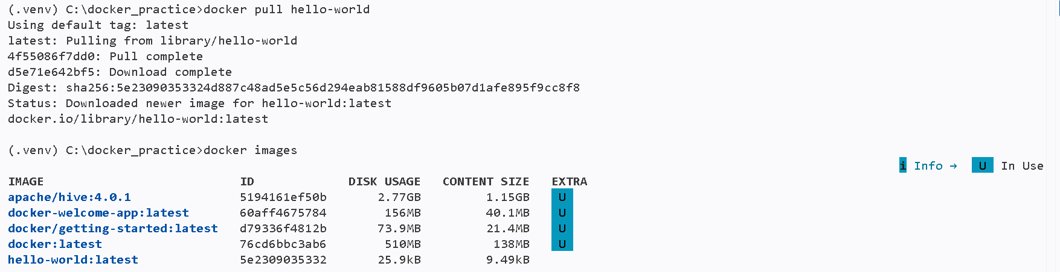
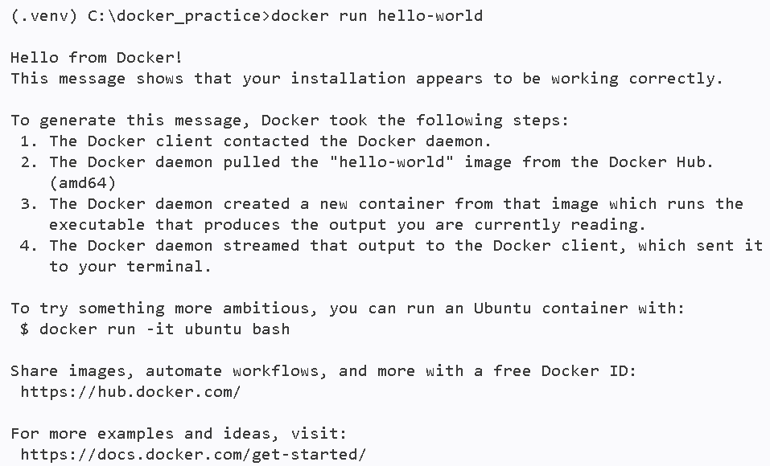
----------------------------------------------------------
Example-2: redis
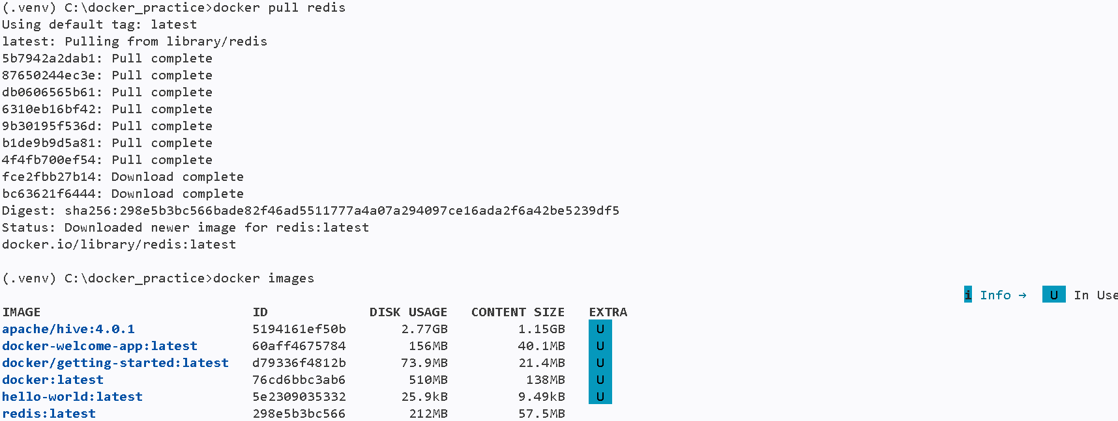
(.venv) C:\docker_practice>docker run redis
Starting Redis Server
1:C 17 Sep 2026 05:50:37.511 * oO0OoO0OoO0Oo Redis is starting oO0OoO0OoO0Oo
1:C 17 Sep 2026 05:50:37.511 * Redis version=8.10.1, bits=64, commit=00000000, modified=1, pid=1, just started
1:C 17 Sep 2026 05:50:37.511 * Configuration loaded
1:M 17 Sep 2026 05:50:37.511 * monotonic clock: POSIX clock_gettime
1:M 17 Sep 2026 05:50:37.512 * Running mode=standalone, port=6379.
1:M 17 Sep 2026 05:50:37.513 * <bf> RedisBloom version 8.10.1 (Git=unknown)
1:M 17 Sep 2026 05:50:37.513 * <bf> Registering configuration options: [
1:M 17 Sep 2026 05:50:37.513 * <bf> { bf-error-rate : 0.01 }
1:M 17 Sep 2026 05:50:37.513 * <bf> { bf-initial-size : 100 }
1:M 17 Sep 2026 05:50:37.513 * <bf> { bf-expansion-factor : 2 }
1:M 17 Sep 2026 05:50:37.513 * <bf> { cf-bucket-size : 2 }
1:M 17 Sep 2026 05:50:37.513 * <bf> { cf-initial-size : 1024 }
1:M 17 Sep 2026 05:50:37.513 * <bf> { cf-max-iterations : 20 }
1:M 17 Sep 2026 05:50:37.513 * <bf> { cf-expansion-factor : 1 }
1:M 17 Sep 2026 05:50:37.513 * <bf> { cf-max-expansions : 32 }
1:M 17 Sep 2026 05:50:37.513 * <bf> ]
1:M 17 Sep 2026 05:50:37.513 * Module 'bf' loaded from /usr/local/lib/redis/modules//redisbloom.so
1:M 17 Sep 2026 05:50:37.521 * <search> search-workers default: 12 (min of MAX_WORKER_THREADS=16 and CPU cores)
1:M 17 Sep 2026 05:50:37.521 * <search> Redis version found by RedisSearch : 8.10.1 - oss
1:M 17 Sep 2026 05:50:37.521 * <search> RediSearch version 8.10.0 (Git=)
1:M 17 Sep 2026 05:50:37.522 * <search> gc: ON, prefix min length: 2, min word length to stem: 4, prefix max expansions: 200, query timeout (ms): 500, timeout policy: return, oom policy: return, cursor read size: 1000, cursor max idle (ms): 300000, max doctable size: 1000000, max number of search results: 1000000, default scorer: BM25STD,
1:M 17 Sep 2026 05:50:37.522 * <search> Initialized thread pools!
1:M 17 Sep 2026 05:50:37.522 * <search> Enabled workers threadpool of size 12
1:M 17 Sep 2026 05:50:37.522 * <search> Subscribe to config changes
1:M 17 Sep 2026 05:50:37.522 * <search> Subscribe to cluster slot migration events
1:M 17 Sep 2026 05:50:37.522 * <search> Subscribe to cluster topology change events
1:M 17 Sep 2026 05:50:37.522 * <search> Enabled role change notification
1:M 17 Sep 2026 05:50:37.523 * <search> Cluster configuration: AUTO partitions, type: 0, coordinator timeout: 0ms
1:M 17 Sep 2026 05:50:37.524 * Module 'search' loaded from /usr/local/lib/redis/modules//redisearch.so
1:M 17 Sep 2026 05:50:37.525 * <timeseries> RedisTimeSeries version 81000, git_sha=
1:M 17 Sep 2026 05:50:37.526 * <timeseries> Redis version found by RedisTimeSeries : 8.10.1 - oss
1:M 17 Sep 2026 05:50:37.526 * <timeseries> Registering configuration options: [
1:M 17 Sep 2026 05:50:37.526 * <timeseries> { ts-compaction-policy : }
1:M 17 Sep 2026 05:50:37.526 * <timeseries> { ts-num-threads : 3 }
1:M 17 Sep 2026 05:50:37.526 * <timeseries> { ts-libmr-protocol : INTERNAL }
1:M 17 Sep 2026 05:50:37.526 * <timeseries> { ts-retention-policy : 0 }
1:M 17 Sep 2026 05:50:37.526 * <timeseries> { ts-duplicate-policy : block }
1:M 17 Sep 2026 05:50:37.526 * <timeseries> { ts-chunk-size-bytes : 4096 }
1:M 17 Sep 2026 05:50:37.526 * <timeseries> { ts-encoding : compressed }
1:M 17 Sep 2026 05:50:37.526 * <timeseries> { ts-ignore-max-time-diff: 0 }
1:M 17 Sep 2026 05:50:37.526 * <timeseries> { ts-ignore-max-val-diff : 0.000000 }
1:M 17 Sep 2026 05:50:37.526 * <timeseries> { ts-topology-events : true }
1:M 17 Sep 2026 05:50:37.526 * <timeseries> ]
1:M 17 Sep 2026 05:50:37.527 * <timeseries> Detected redis oss (cluster-enabled=no)
1:M 17 Sep 2026 05:50:37.529 * <timeseries> Subscribe to ASM events
1:M 17 Sep 2026 05:50:37.529 * <timeseries> Subscribe to topology changes events
1:M 17 Sep 2026 05:50:37.529 * <timeseries> Enabled diskless replication
1:M 17 Sep 2026 05:50:37.529 * Module 'timeseries' loaded from /usr/local/lib/redis/modules//redistimeseries.so
1:M 17 Sep 2026 05:50:37.531 * <ReJSON> Created new data type 'ReJSON-RL'
1:M 17 Sep 2026 05:50:37.531 * <ReJSON> version: 81000 git sha: unknown branch: unknown
1:M 17 Sep 2026 05:50:37.531 * <ReJSON> Exported RedisJSON_V1 API
1:M 17 Sep 2026 05:50:37.531 * <ReJSON> Exported RedisJSON_V2 API
1:M 17 Sep 2026 05:50:37.531 * <ReJSON> Exported RedisJSON_V3 API
1:M 17 Sep 2026 05:50:37.531 * <ReJSON> Exported RedisJSON_V4 API
1:M 17 Sep 2026 05:50:37.531 * <ReJSON> Exported RedisJSON_V5 API
1:M 17 Sep 2026 05:50:37.531 * <ReJSON> Exported RedisJSON_V6 API
1:M 17 Sep 2026 05:50:37.531 * <ReJSON> Exported RedisJSON_V7 API
1:M 17 Sep 2026 05:50:37.531 * <ReJSON> Exported RedisJSON_V8 API
1:M 17 Sep 2026 05:50:37.531 * <ReJSON> Enabled diskless replication
1:M 17 Sep 2026 05:50:37.531 * <ReJSON> Initialized shared string cache, thread safe: true.
1:M 17 Sep 2026 05:50:37.531 * Module 'ReJSON' loaded from /usr/local/lib/redis/modules//rejson.so
1:M 17 Sep 2026 05:50:37.531 * <search> Acquired RedisJSON_V8 API
1:M 17 Sep 2026 05:50:37.532 * Server initialized
1:M 17 Sep 2026 05:50:37.532 * Ready to accept connections tcp
1:M 17 Sep 2026 05:50:37.532 # WARNING: Redis does not require authentication and is not protected by network restrictions. Redis will accept connections from any IP address on any network interface.
--------------------------------------------------------
Example-3: ubuntu
docker run -it (The Interactive Terminal)
You will never use -it with docker build. You use it with docker run. The -it is actually two separate flags combined:
- -i (Interactive): Keeps the input stream (STDIN) open, allowing you to type commands into the container.
- -t (TTY): Allocates a pseudo-terminal. This gives you a formatted command-line interface with a prompt, text wrapping, and colors.
- Combined (-it): This hooks your keyboard and screen directly up to the inside of the running container so you can interact with it just like a normal computer terminal.
- The -it flags (Interactive TTY): Connects your keyboard and screen to the container so you can interact with it.
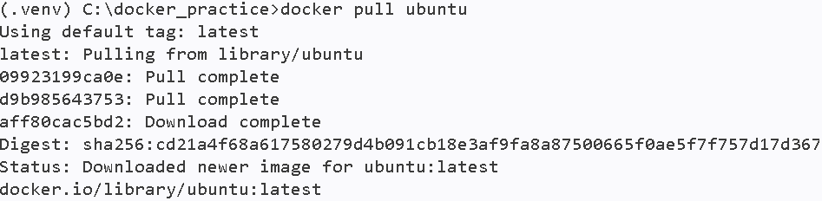
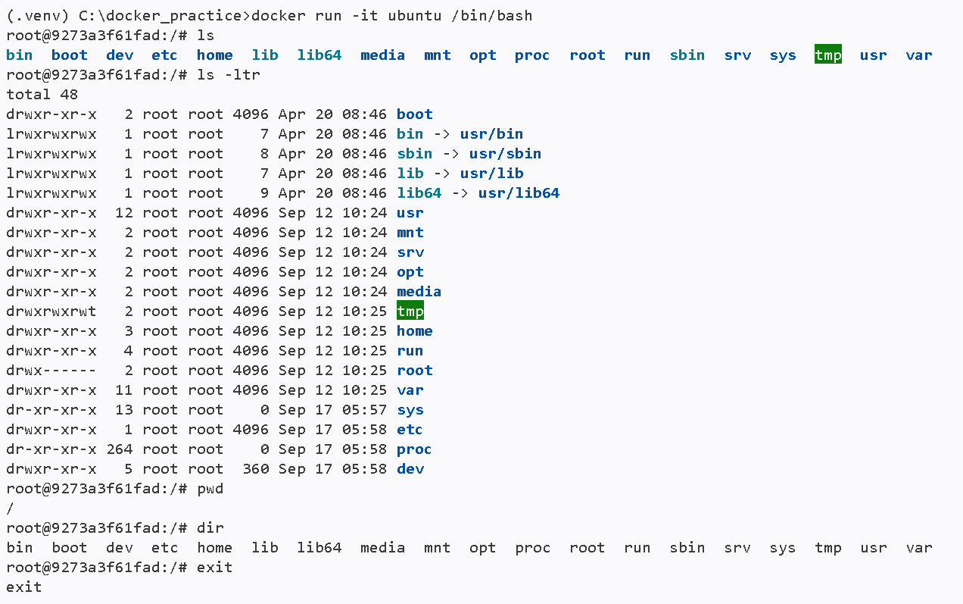
==================================================================================
Delete or Remove pulled image from list of images
Check running containers:
> docker ps
Check all containers, including stopped ones: -a stands for all
> docker ps -a
Stop a running container:
> docker stop <container_name_or_id>
Remove a container:
> docker rm <container_name_or_id>
remove the image: In Docker, rmi stands for remove image.
> docker image rm <image_name_or_id > (or) docker rmi <image_name_or_id >
ex: docker image rm docker-welcome-app:latest
or
docker rmi docker-welcome-app
---------------------------------------------------------------------------------
Error case in deleting docker image in use status backed by associated container which is running or stopped but not removed
Error:
(.venv) C:\docker_practice>docker rmi cd21a4f68a61
Error response from daemon: conflict: unable to delete cd21a4f68a61 (must be forced) - image is being used by stopped container 9273a3f61fad

(.venv) C:\docker_practice>docker rmi 298e5b3bc566
Error response from daemon: conflict: unable to delete 298e5b3bc566 (must be forced) - image is being used by stopped container 9918af160233

Solution:
A stopped container can still reference an image, so Docker will not remove it automatically.
Remove the stopped container first:
> docker rm 9918af160233
> docker rmi 298e5b3bc566

Or force-remove the image directly:
> docker rmi -f 298e5b3bc566

The first option is safer because it removes the specific stopped container before deleting the Redis or any image.
Flow:
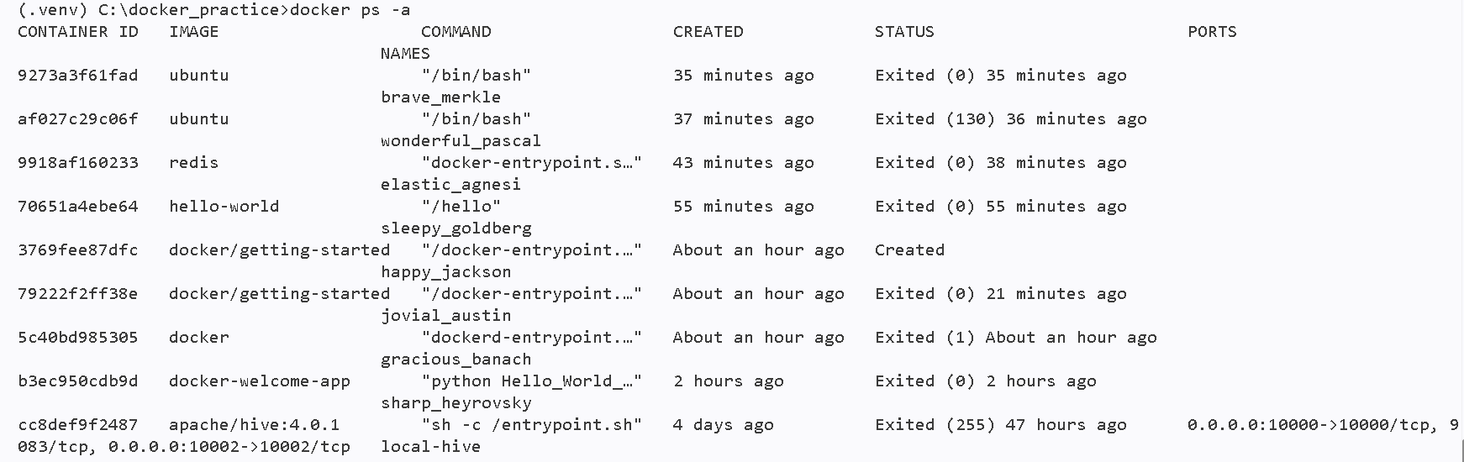
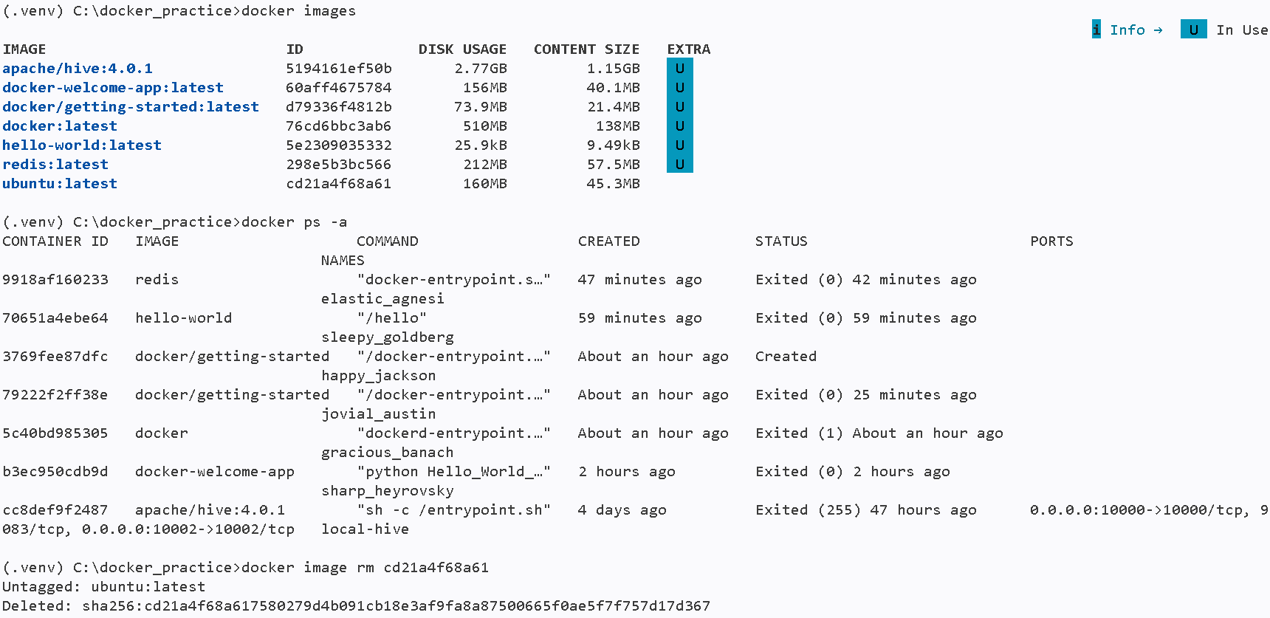
---> remove forcefully
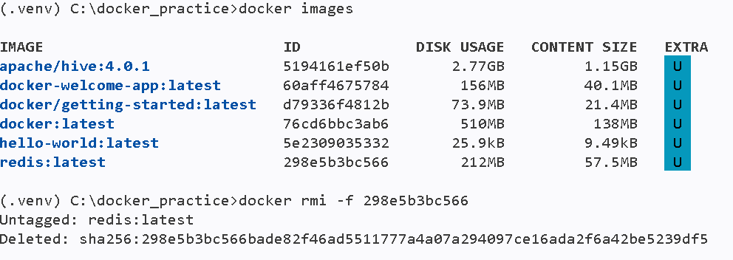
-----------------------------------------------------------------------------
Push Docker Image To Docker Hub
DockerHub login with credentials:
> docker login
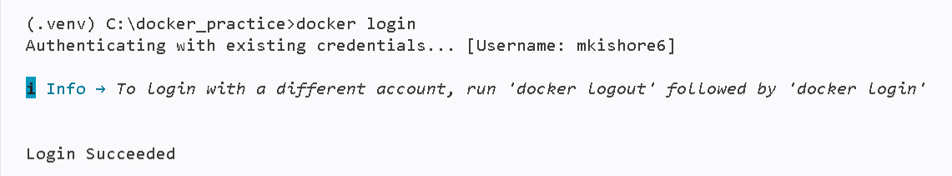
Rebuilding docker images with username :
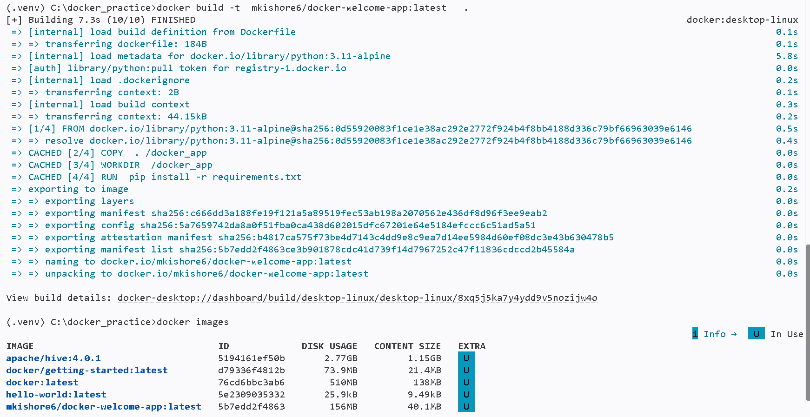

Rename a docker image:
> docker tag <old-image-name> <new-image-name>
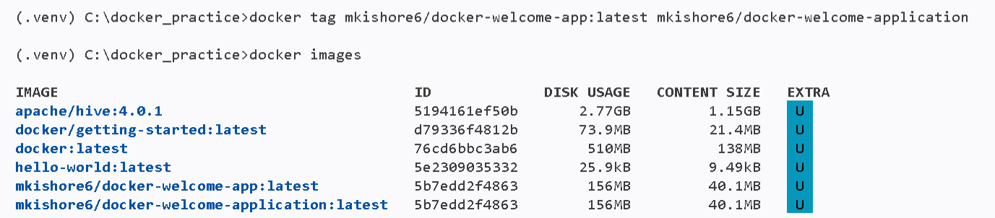

Push image to Docker Hub Repository:
> docker push <docker-image-name> : <version-name>
Attributes:
version-name – specifies version of the docker image
it will be latest or any version name like 1.0.0,1.0.1,2.0.0 etc…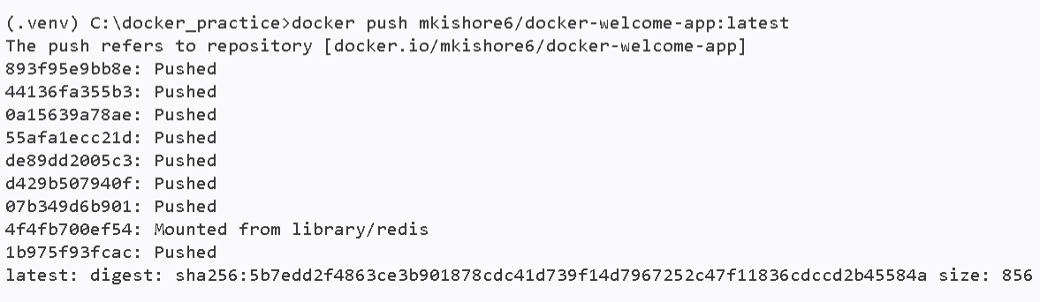
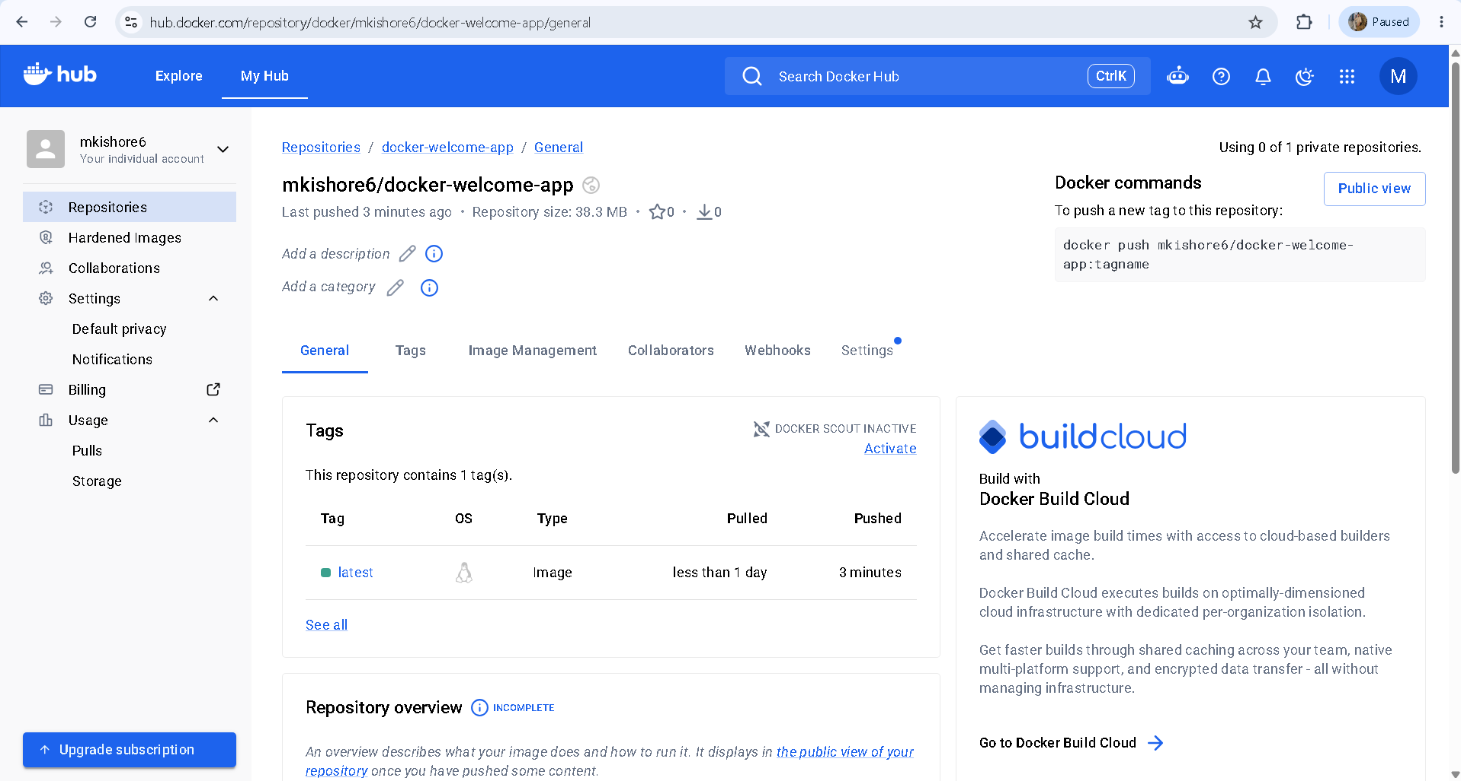
Deleting current running container or existing docker image afterwards pull same docker image from docker hub repository which we pushed recently:
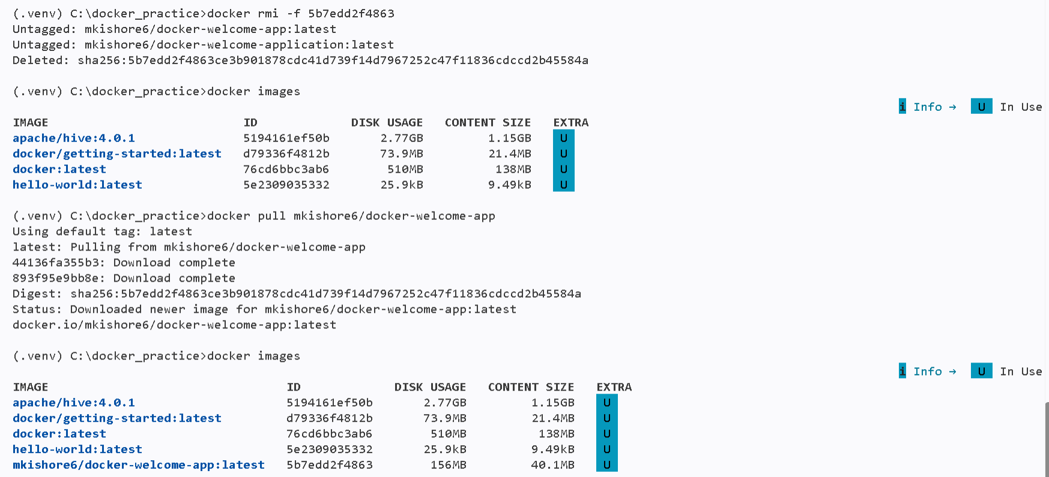
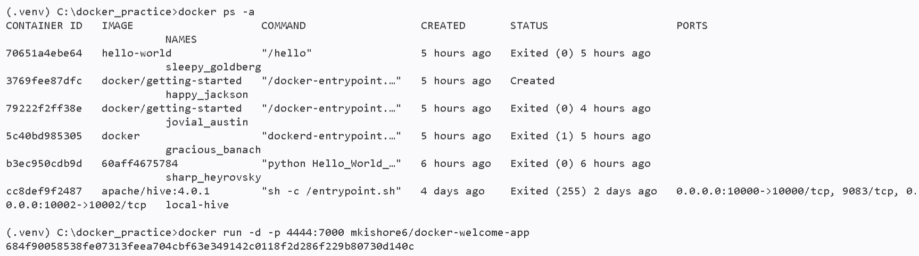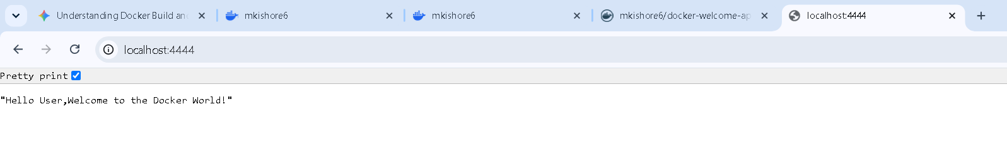
Docker hub link: https://hub.docker.com/repositories/mkishore6?_gl=1*8qedig*_gcl_au*MTQ5ODU5NDc2MC4xNzg4NjA0MjM0*_ga*NjQ5NjY1Mzg3LjE3ODg2MDQyMzQ.*_ga_XJWPQMJYHQ*czE3ODk2MzU2NzUkbzMkZzEkdDE3ODk2MzY1NzAkajYwJGwwJGgw
==================================================================================

Docker Compose
Understanding Docker Compose
- Purpose: A tool used for defining and running multi-container Docker applications.
- The Problem: In real-world applications, a web app often relies on external services like MySQL, MongoDB, or Redis. It is not viable to run these databases inside the same container as the web app; they must run as separate, independent containers.
- The Solution: Docker Compose uses a single configuration file (docker-compose.yml) to define, link, and run all these separate containers simultaneously, allowing them to communicate with one another.
Setting Up the Web Application (Dockerfile)
Before using Compose, the main application requires a Dockerfile to dictate its specific environment and execution steps.
Lecturers Example Flow:
- Base Image: Defined using FROM python:3.7-alpine. Alpine Linux is chosen for its extremely small size and fast build speed.
- Working Directory: WORKDIR /code establishes the primary folder inside the container.
- Copying Files: COPY . . transfers the application code from the local host repository into the container's working directory.
- Environment Variables: Set using ENV as key-value pairs (e.g., FLASK_APP=app.py and RUN_HOST=0.0.0.0) so the framework knows how to run.
- Dependencies: Installed via RUN pip install -r requirements.txt.
- Port Exposing: EXPOSE 5000 specifies the internal container port that will be exposed.
- Execution Command: CMD ["flask", "run"] provides the final instruction to boot up the web application.
Configuring the docker-compose.yml File
This YAML file orchestrates the multi-container architecture. Note: Proper indentation is critical in YAML files; incorrect spacing will cause syntax errors during the build process.
Core Structure
- Version: Declares the Compose syntax version (e.g., version: '3.0').
- Services: The primary block where every container is defined as an individual service (e.g., web, redis, mysql).

Defining Services
- Custom Web Service (The Flask App):
  - Build Context: Using build: . instructs Compose to build the image using the Dockerfile located in the current root directory.
  - Ports: Maps the external host machine port to the internal container port (e.g., 8000:5000).
- Pre-Built Services (Redis / MySQL):
  - Image Pulling: Infrastructure services do not require custom Dockerfiles. Using image: redis or image: mysql tells Compose to pull the official pre-built images directly from the Docker Hub repository.
  - Default Allocation: Pre-built images from Docker Hub will automatically assign default ports (like 6379 for Redis) unless manually overridden.
Essential Commands & Lifecycle
- docker-compose up: Executes the YAML file line-by-line. It pulls necessary images from Docker Hub, builds local Dockerfiles, and starts all containers in the correct sequence.
- docker-compose stop: Safely halts all running containers associated with the Compose file without deleting the underlying images.
- Verification:
  - docker images: Displays the newly built and pulled images on your machine.
  - docker ps: Lists the actively running containers and shows how they are communicating across ports.
- Handling Code Updates: Modifying the underlying application code (like changing a return message from "Hello Krish" to "Hello Dockers") will not automatically reflect in a running container. To see the changes, you must stop the container, rebuild the images, and run them again.
Realtime Example :
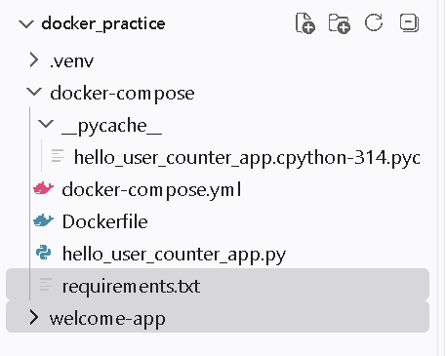
C:\docker_practice\docker-compose\hello_user_counter_app.py
import os
from contextlib import asynccontextmanager

from fastapi import FastAPI, HTTPException, Request
from redis.asyncio import Redis
from redis.exceptions import RedisError

# Reading environment variables
REDIS_URL = os.getenv("REDIS_URL", "redis://localhost:6379/0")
COUNTER_KEY = os.getenv("COUNTER_KEY", "hello-user:endpoint-hits")

@asynccontextmanager
async def lifespan(app: FastAPI):
app.state.redis = Redis.from_url(REDIS_URL, decode_responses=True)
try:
# await app.state.redis.ping()
# raises error redis.exceptions.ConnectionError: Error Multiple exceptions: [Errno 111] Connect call failed ('::1', 6379, 0, 0), [Errno 111] Connect call failed ('127.0.0.1', 6379) connecting to localhost:6379.
yield
finally:
await app.state.redis.aclose()

app = FastAPI(title="Hello User Counter", lifespan=lifespan)

@app.get("/")
async def hello_user(request: Request) -> dict[str, str | int]:
try:
count = await request.app.state.redis.incr(COUNTER_KEY)
except RedisError as error:
raise HTTPException(
status_code=503,
detail="Redis is unavailable",
) from error

return {
"message": f"hello user, you accessed this endpoint {count} many times",
"count": count,
}

if __name__ == "__main__":
import uvicorn

uvicorn.run("hello_user_counter_app:app", host="0.0.0.0", port=8000)
----------------------------------------
C:\docker_practice\docker-compose\Dockerfile
FROM python:3.11-alpine
WORKDIR /docker-code-dir
COPY . .
RUN pip install --no-cache-dir -r requirements.txt
EXPOSE 8000
CMD ["python", "hello_user_counter_app.py"]
-------------------------------------------
C:\docker_practice\docker-compose\docker-compose.yml
services:
web:
image: docker-web-app
build: .
environment:
REDIS_URL: redis://redis:6379/0
depends_on:
redis:
condition: service_healthy
ports:
- "5000:8000"

redis:
image: redis:7-alpine
healthcheck:
test: ["CMD", "redis-cli", "ping"]
interval: 5s
timeout: 3s
retries: 5
--------------------------------------------
C:\docker_practice\docker-compose\requirements.txt
fastapi
redis
uvicorn
-----------------------------------------------
Run compose commands:
==> Starting docker compose in docker-compose.yaml file exist work directory:
> docker compose up

==> Stopping docker compose:
> docker compose stop
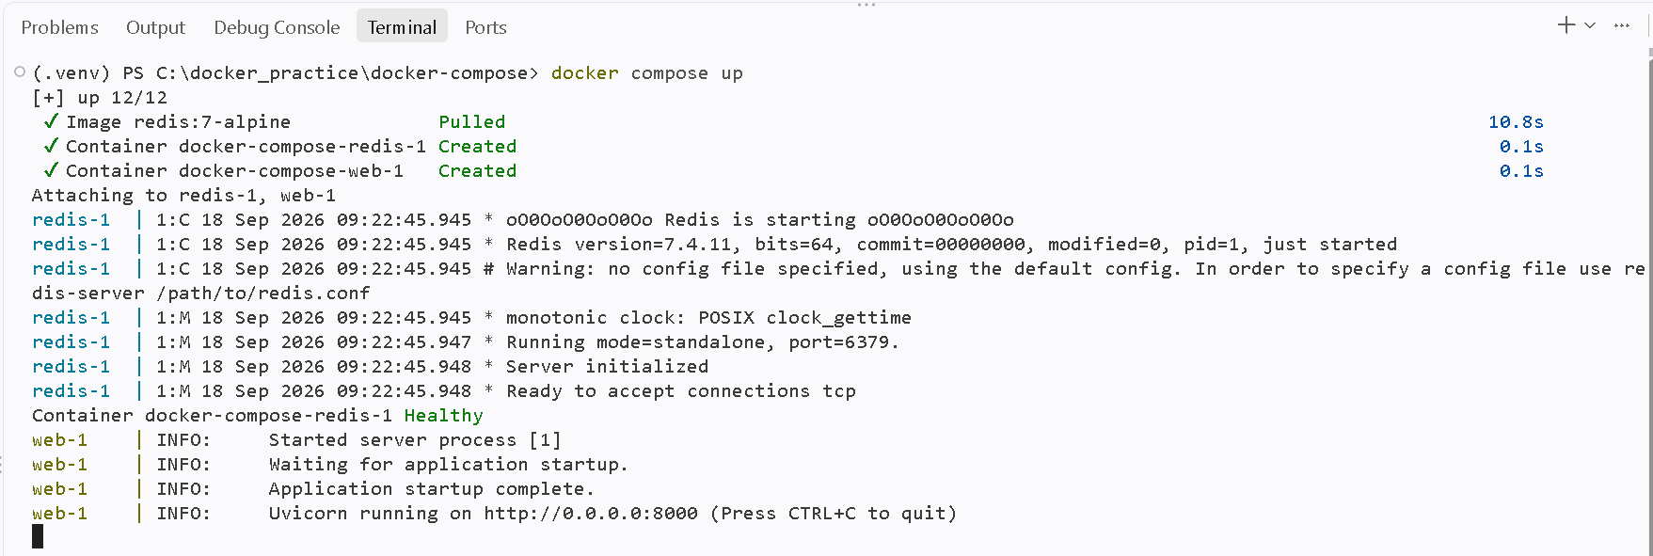
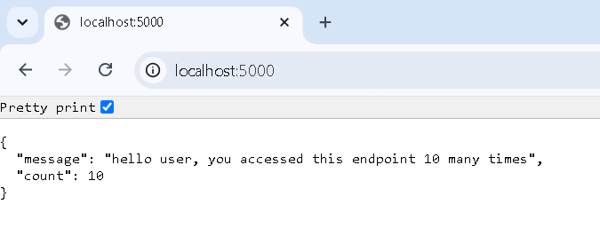
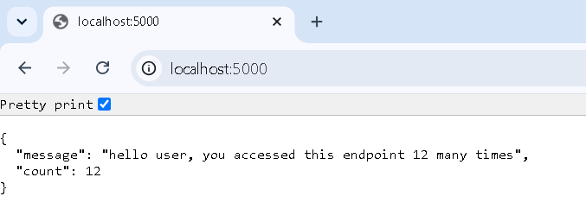
-------------------------------------------------------------------

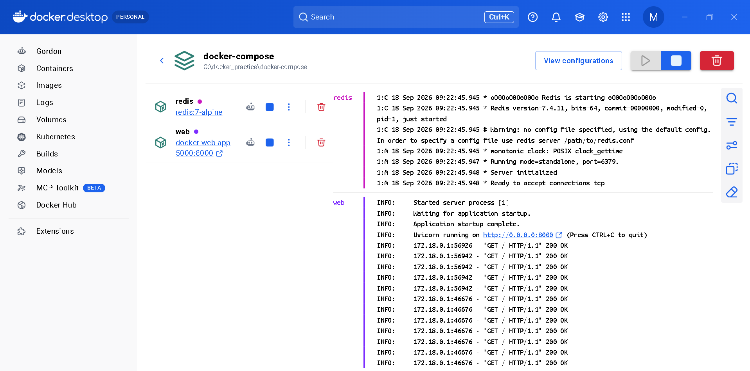
Note:
Handling Code Updates:
Modifying the underlying application code (like changing a return message from "Hello User" to "Hello Dockers") will not automatically reflect in a running container. To see the changes, you must stop the container, rebuild the images, and run them again.
Way-1: Rebuilding the docker image and compose to view changes updated newly:
> docker compose up –build
Flow:
Running docker-compose up --build forces Docker to ignore the existing image and recreate it from scratch, which absolutely reflects your latest code changes in the output.
When you append the --build flag, Compose runs through your Dockerfile step-by-step again. When it hits the COPY . . command, it pulls your newly saved local files and bakes them into this fresh image.
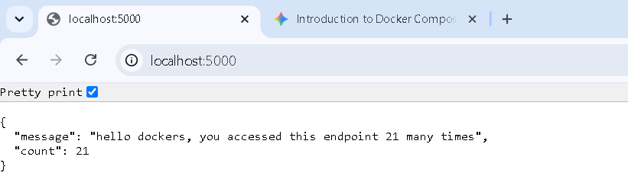
Way-2: Implementing docker volumes concept in docker-compose example:
Add volumes key property by specifying current working directory as host and WORKDIR as destination in container.
C:\docker_practice\docker-compose\docker-compose.yml
services:
web:
image: docker-web-app
build: .
environment:
REDIS_URL: redis://redis:6379/0
depends_on:
redis:
condition: service_healthy
ports:
- "5000:8000"
volumes:
- .:/docker-code-dir

redis:
image: redis:7-alpine
healthcheck:
test: ["CMD", "redis-cli", "ping"]
interval: 5s
timeout: 3s
retries: 5
Breaking Down the Syntax (.:/docker-code-dir)
The mapping uses a HOST:CONTAINER format:
- The left side (.): Represents your local host machine. The dot means "the current directory" where your docker-compose.yml lives.
- The colon (:): The mapping bridge.
- The right side (/docker-code-dir): Represents the destination folder inside the container. This should match the WORKDIR you defined in your Dockerfile.
By adding those two lines under the volumes key, Compose will override the static files copied during the build and instead mount your live directory into /code. You can now change your Python code, hit save, and refresh your browser without ever typing docker-compose up --build again.
Implementing volumes to sync old data with new containers:
Deleting all containers and images:
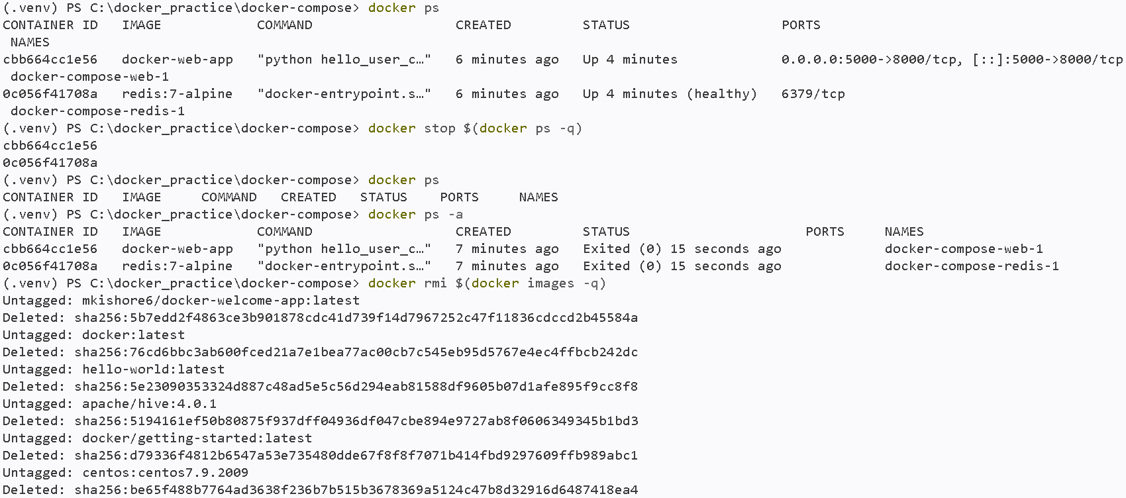
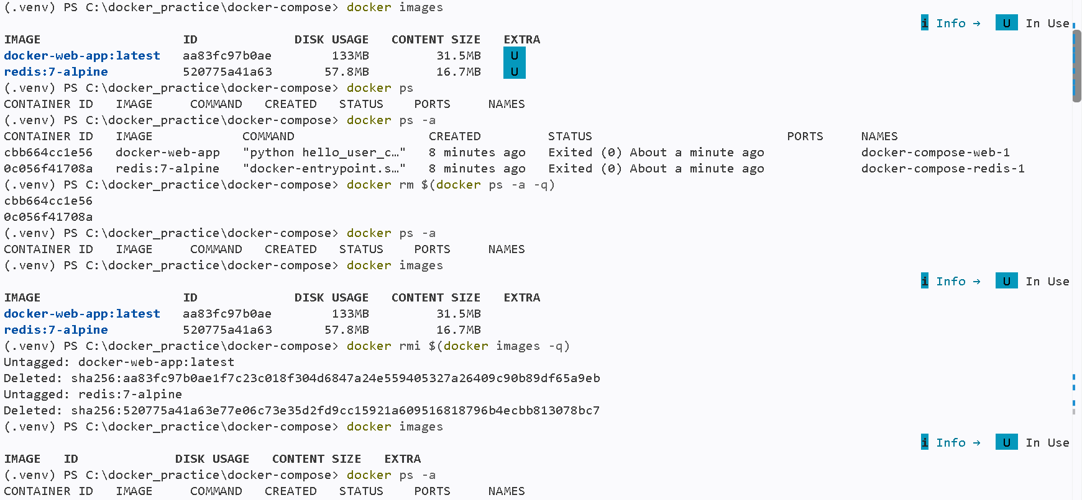
Building docker compose with actual code “Hello Users ….” Message only:
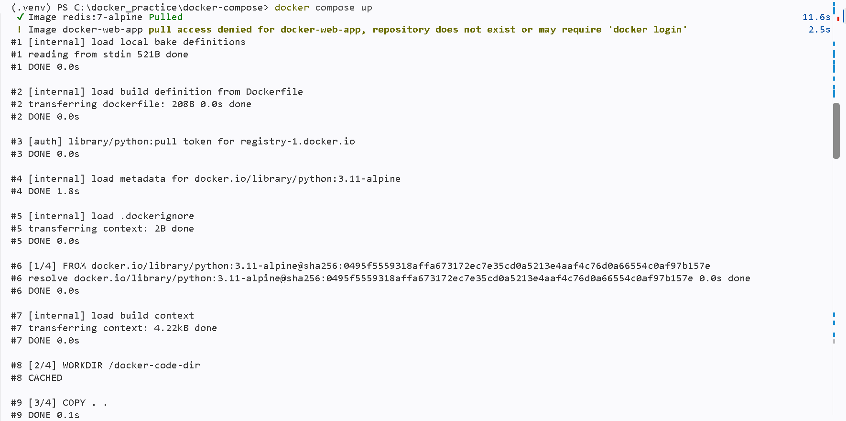
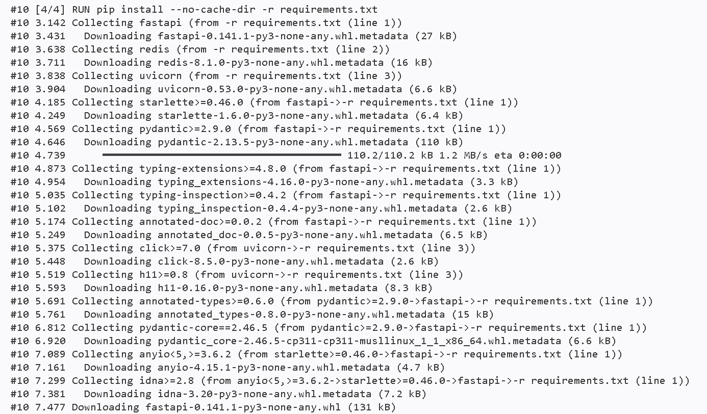
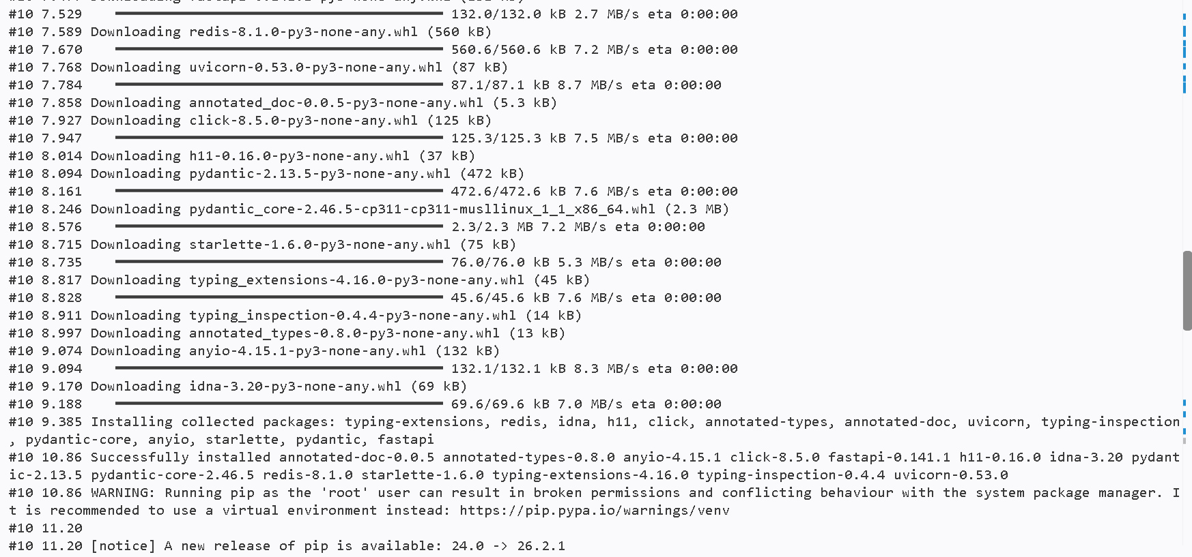
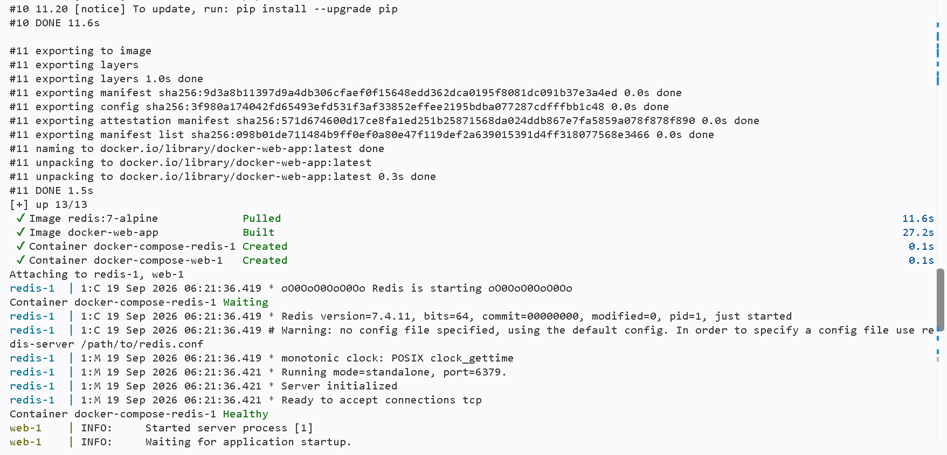
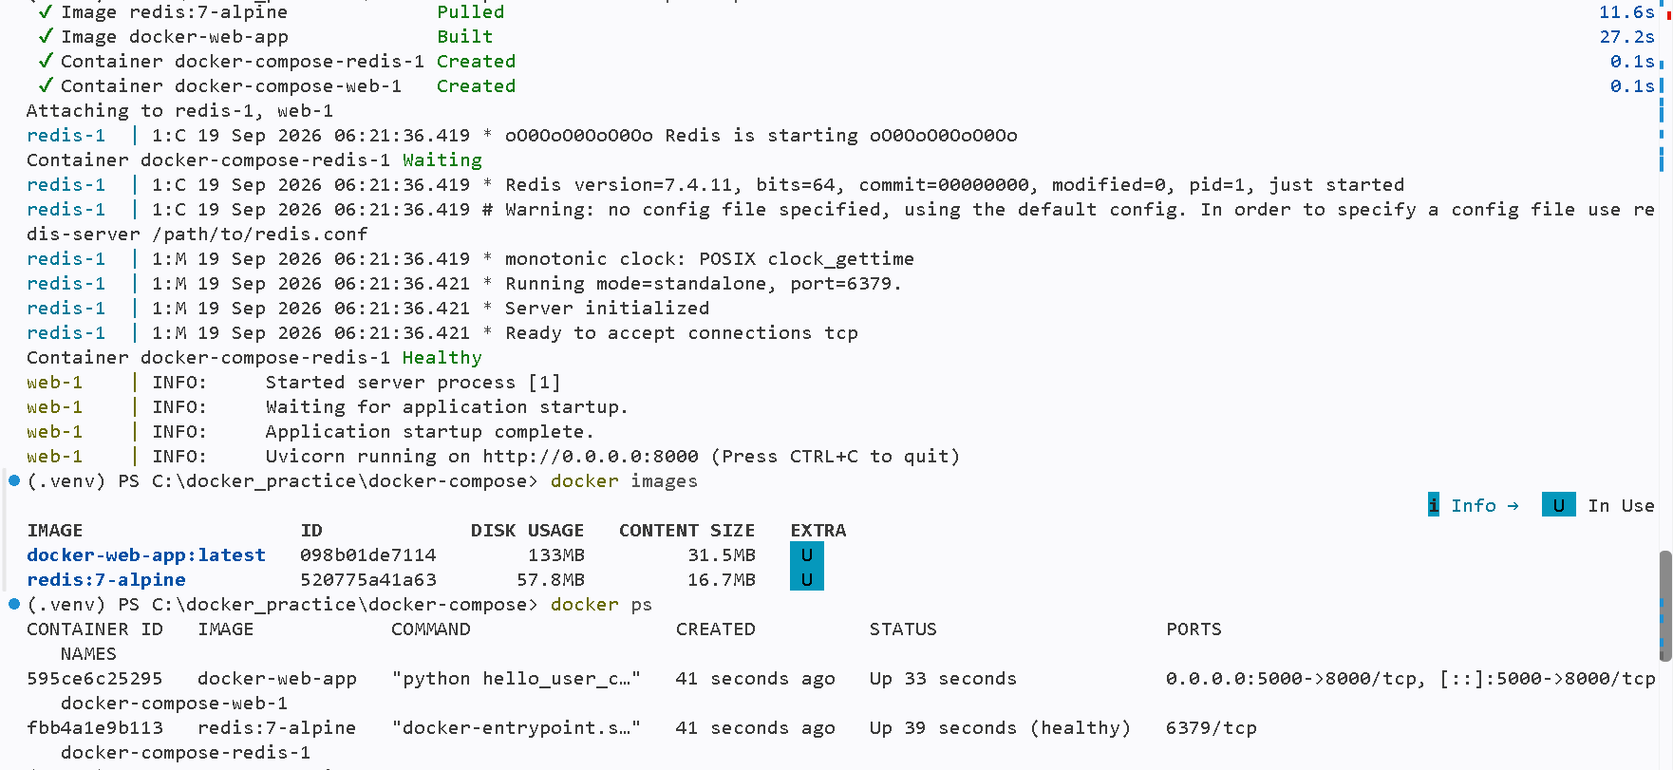
Code changes from Hello Users to Hello Dockers
C:\docker_practice\docker-compose\hello_user_counter_app.py
import os
from contextlib import asynccontextmanager

from fastapi import FastAPI, HTTPException, Request
from redis.asyncio import Redis
from redis.exceptions import RedisError

# Reading environment variables
REDIS_URL = os.getenv("REDIS_URL", "redis://localhost:6379/0")
COUNTER_KEY = os.getenv("COUNTER_KEY", "hello-user:endpoint-hits")

@asynccontextmanager
async def lifespan(app: FastAPI):
app.state.redis = Redis.from_url(REDIS_URL, decode_responses=True)
try:
# await app.state.redis.ping() # redis.exceptions.ConnectionError: Error Multiple exceptions: [Errno 111] Connect call failed ('::1', 6379, 0, 0), [Errno 111] Connect call failed ('127.0.0.1', 6379) connecting to localhost:6379.
yield
finally:
await app.state.redis.aclose()

app = FastAPI(title="Hello User Counter", lifespan=lifespan)

@app.get("/")
async def hello_user(request: Request) -> dict[str, str | int]:
try:
count = await request.app.state.redis.incr(COUNTER_KEY)
except RedisError as error:
raise HTTPException(
status_code=503,
detail="Redis is unavailable",
) from error

return {
"message": f"hello dockers, you accessed this endpoint {count} many times",
"count": count,
}

if __name__ == "__main__":
import uvicorn

uvicorn.run("hello_user_counter_app:app", host="0.0.0.0", port=8000)
Testing:
--> I Tried 7 times to check code changes reflect in http://localhost:5000/ but nothing changed in response because previous container still running and not syncing the changes.
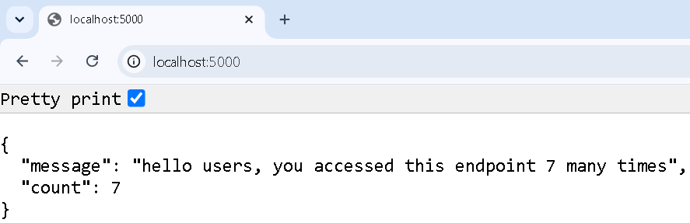
Stop previous container and rerun same container without re-building docker image:
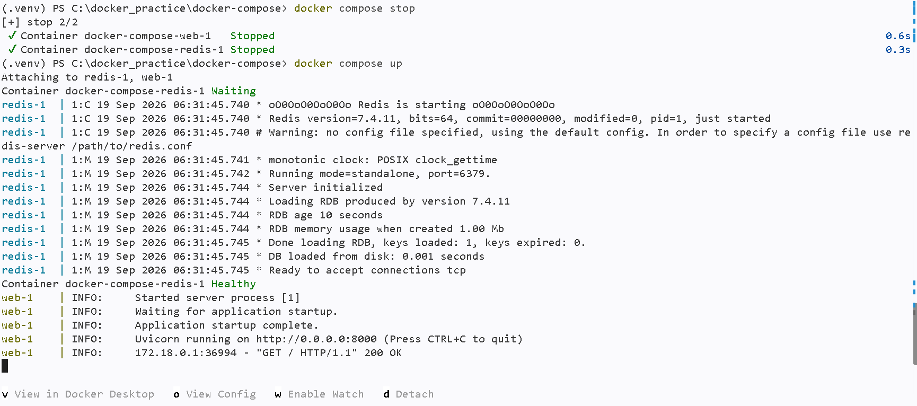
Note: here volumes property is working fine.because after rerun docker compose, code changes reflected along with previous endpoint hitcount updated to 8 times instead of starts with 1.
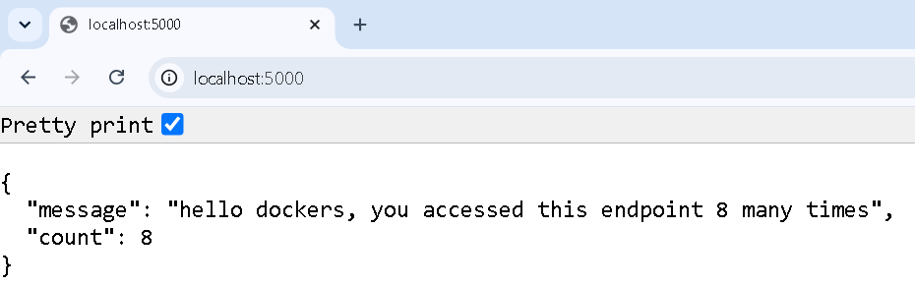
=================================================================================
Docker Volumes
Why docker volumes?
By default, when a Docker container is deleted, all the data inside it vanishes. Volumes fix this by storing data on your local machine instead, safely outside the container.
Role of docker volume in docker compose:
1. Data Persistence (Database Protection)
If you run a MySQL or PostgreSQL container, you absolutely cannot lose your user data every time you restart the container or run docker-compose down.
You use a Named Volume for this. Docker manages this folder automatically somewhere on your hard drive, keeping the database data safe even if the container is completely destroyed.
2. Live Code Reloading (Development)
Instead of letting Docker manage the folder, you tell Docker to point directly at your specific project folder. This gives your container real-time access to code changes you make in your IDE. this is done using a Bind Mount
3. Sharing Data Between Containers
Sometimes, multiple containers need access to the exact same files. For example, a backend Python app might generate PDF reports, and an Nginx web server container needs to serve those PDFs to users.
Example:
To check docker network :
> docker network ls
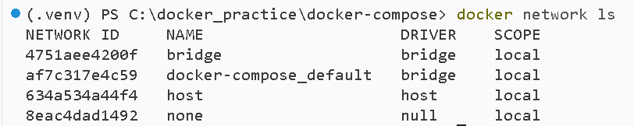
To check existing volumes created by docker:
> docker volume ls
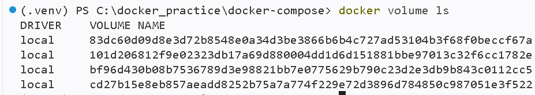

To view details of specific volume:
> docker volume inspect <volume-name>
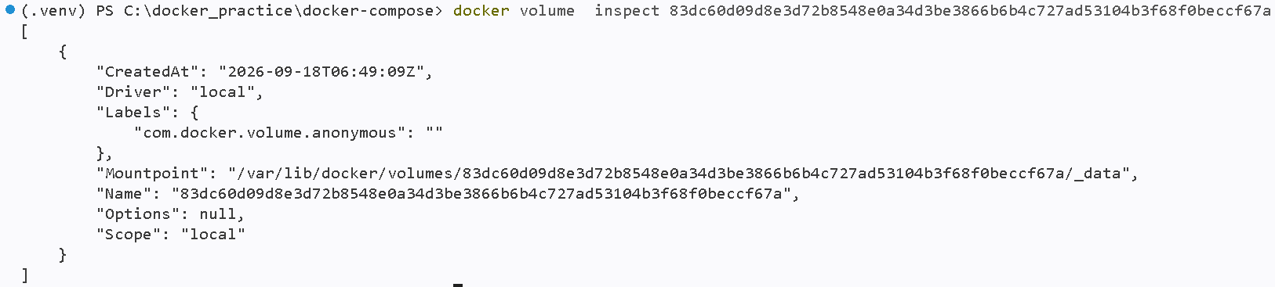
Not Solved:
we tried to access Mountpoint location “ /var/lib/docker/volumes/83dc60d09d8e3d72b8548e0a34d3be3866b6b4c727ad53104b3f68f0beccf67a/_data”
using ubuntu, docker desktop terminal . it was not work because we are not accessing the terminal which connect to container. We failed in to achieve it. It’s not resolved yet.
Deleting Existing Docker Volumes
step-1: delete associated docker containers which are not running or running
> docker ps -a
> docker rm $(docker ps -a -q) deletes all containers even though those are running or not-running
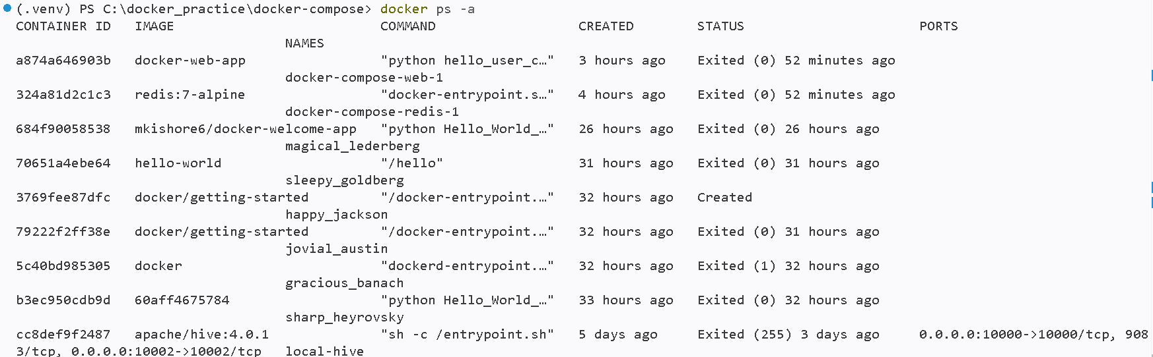
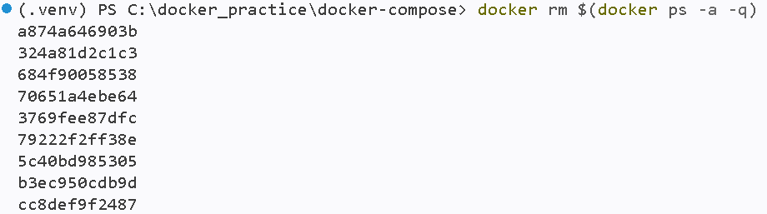
--> If we delete containers still associated volumes exist they were not delete
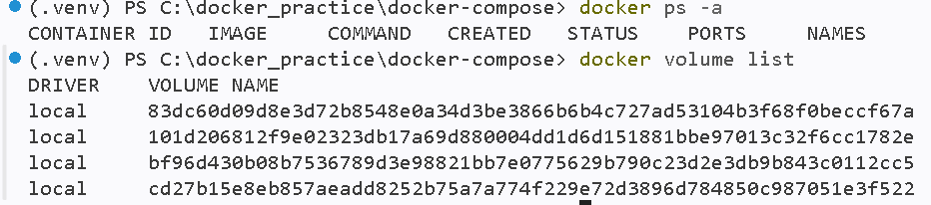
step-2: delete volumes each one
> docker volume rm <volume-name>
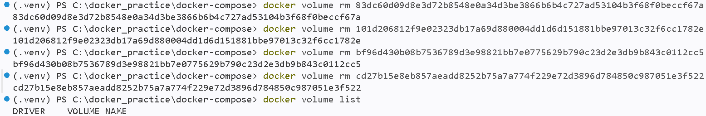
Creating custom docker volumes :
Possible command attributes:
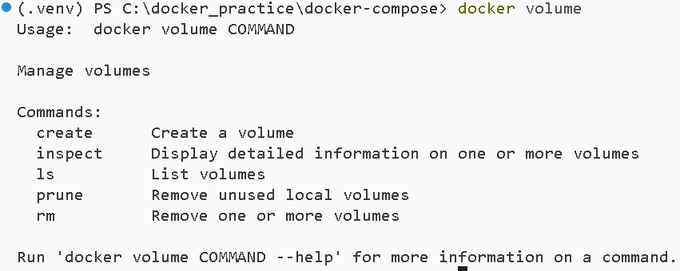

Create command:
> docker volume create <volume-name>
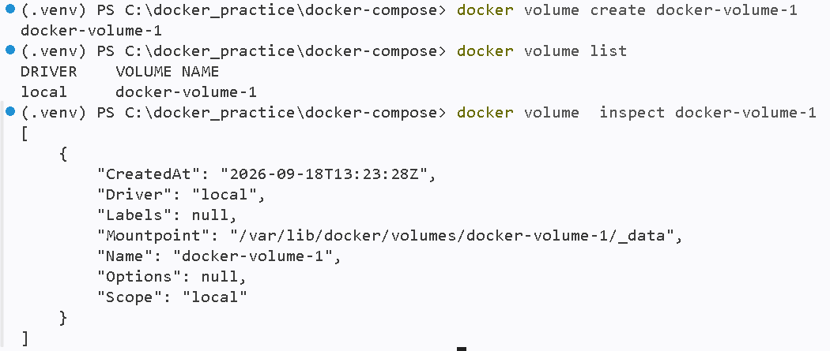
-----------------------------------------------------------------------------
Scenario-1: Mounting a Volume using -v or – mount (3 ways)
Way-1: Using -- mount
Syntax:
> docker run -it -- name=<custom container-name> -- mount source=<docker-volume-name>,destination=<doker-volume-storage-location> <image-name>:<version>

(Bind Mounts)Mounting created docker volume to centos linux based docker image and container published as part of docker hub repository(https://hub.docker.com/_/centos):
> docker run -it --name=centos_mount_container --mount source=docker-volume-1,destination=/data centos:centos7.9.2009
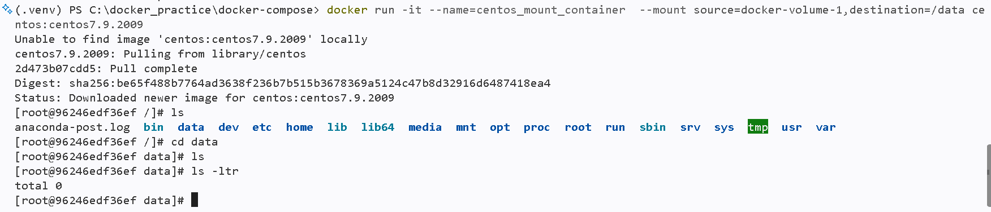
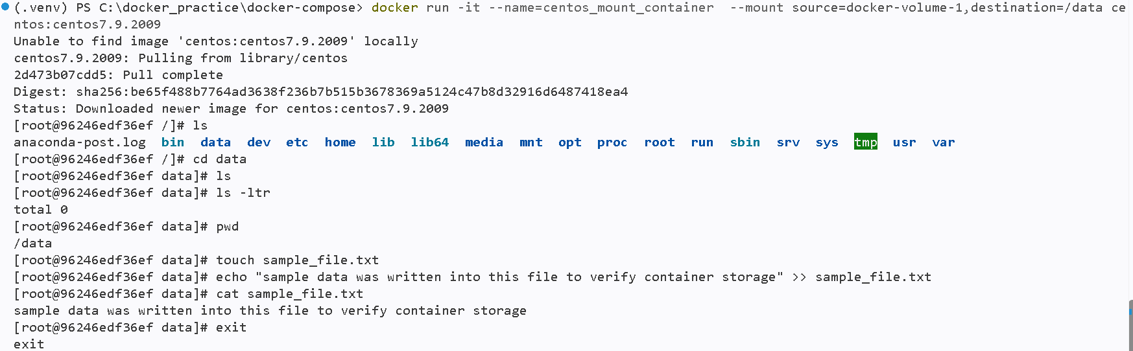
Deleting recently created containers which are mounted to docker-volume-1:
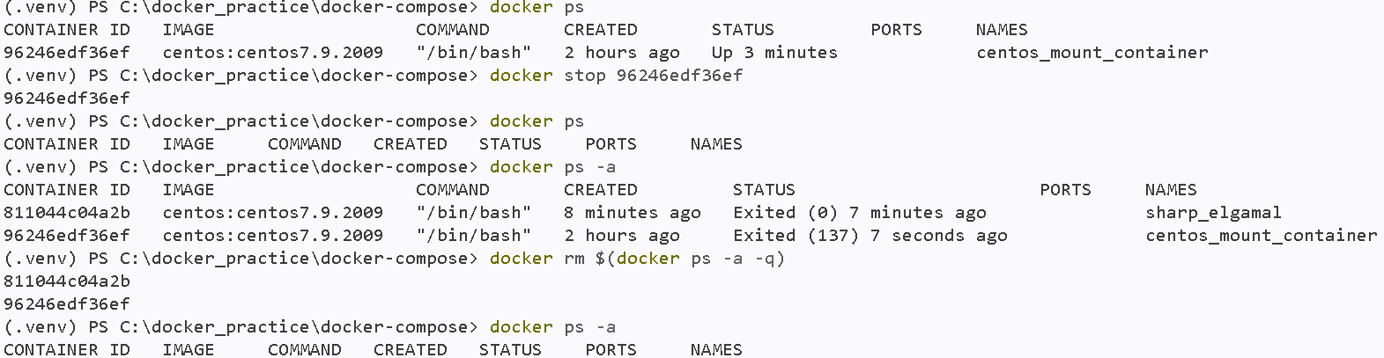
Recreating new container by mounting docker-volume-1 which is still exist (not deleted) and accessing docker-volume-1 -- /data /sample_file.txt in new container :
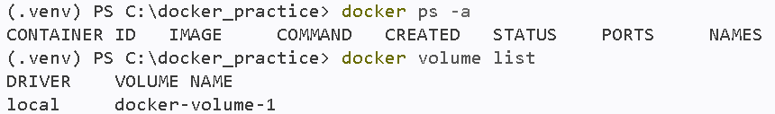
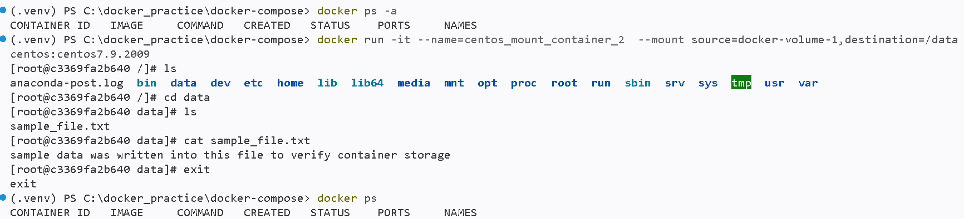
Way-2:Sharing volume data from old container to another newly creating container (-- volumes-from)
Syntax :
> docker run -it -- volumes-from <old-container-name> -- name <new-container-name> <docker-image-name>:<version> <COMMAND from container details>
> docker run -it --volumes-from centos_mount_container_2 --name=centos_mount_container_3 centos:centos7.9.2009 /bin/bash
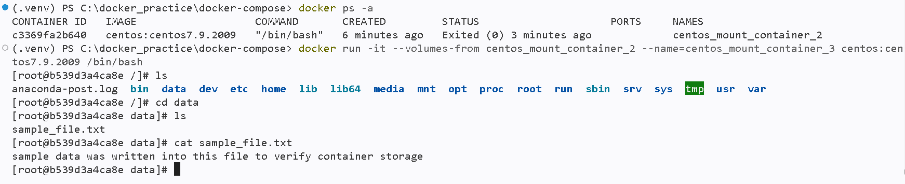
Way-3: Using -v
Syntax:
> docker run -it -- name <container-name> -v <docker-volume-name>:<docker-volume-storage-location> <docker-image-name>:<version>
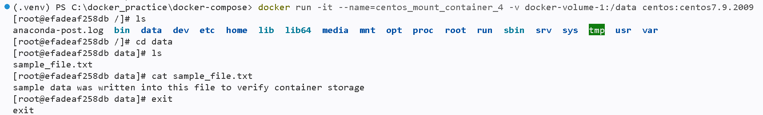
Scenario-2 : creating volume in docker host/ locally (local file system terminal)then mount it to docker container as a docker volume dynamically
Syntax: docker run -it --name=centos_dynamic_container -v "${PWD}:< docker-volume-storage-location >" <docker-image-name>:<version>
> docker run -it --name=centos_dynamic_container -v "${PWD}:/data" centos:centos7.9.2009
